**CREATE CLOUDWATCH ALARM FOR TERMINATING EC2 INSTANCE AND TRIGGERING SNS**

🡺Create an EC2 instance

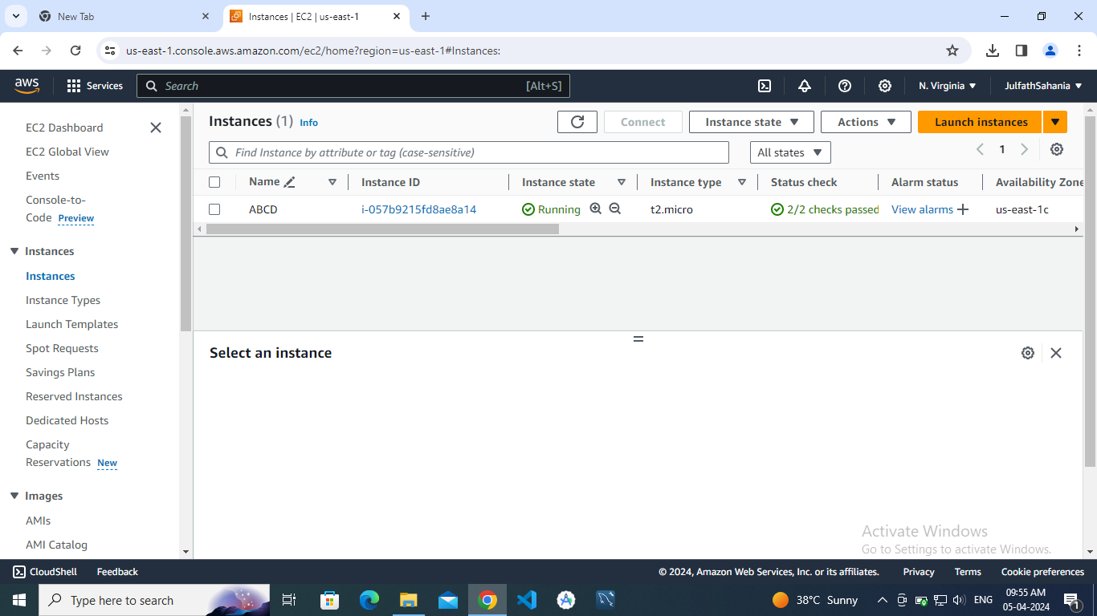

🡺Create SNS notification

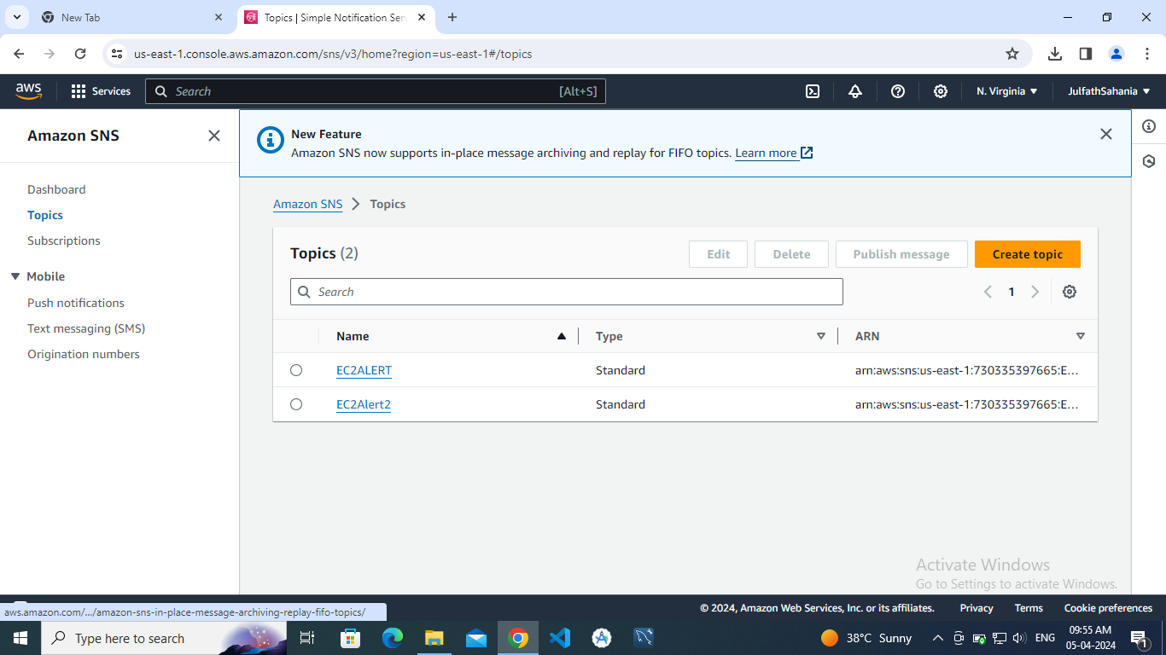

🡺Create a In alarm in cloudwatch

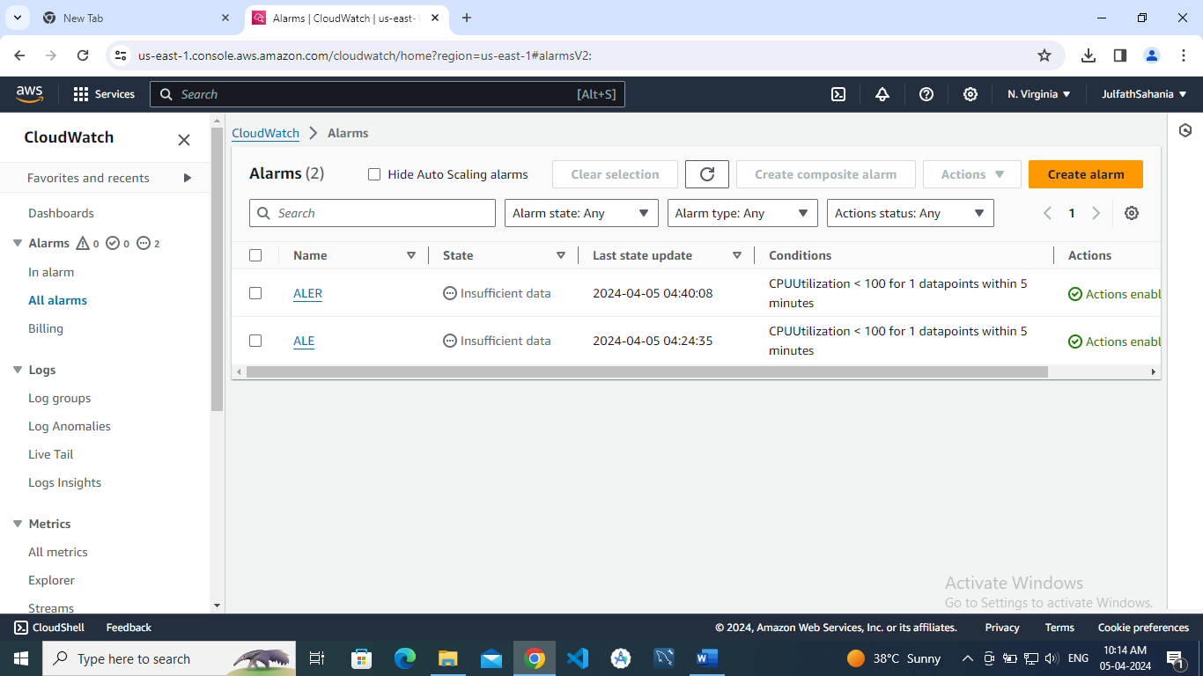

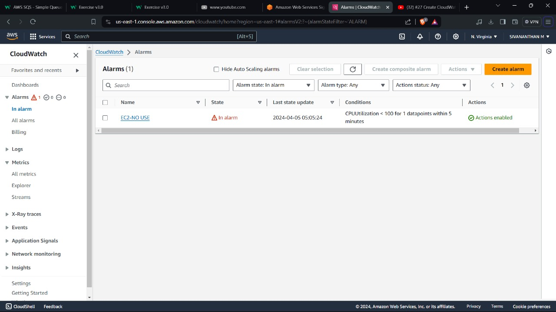

🡺THE INSTANCE SHOULD BE TERMINATED

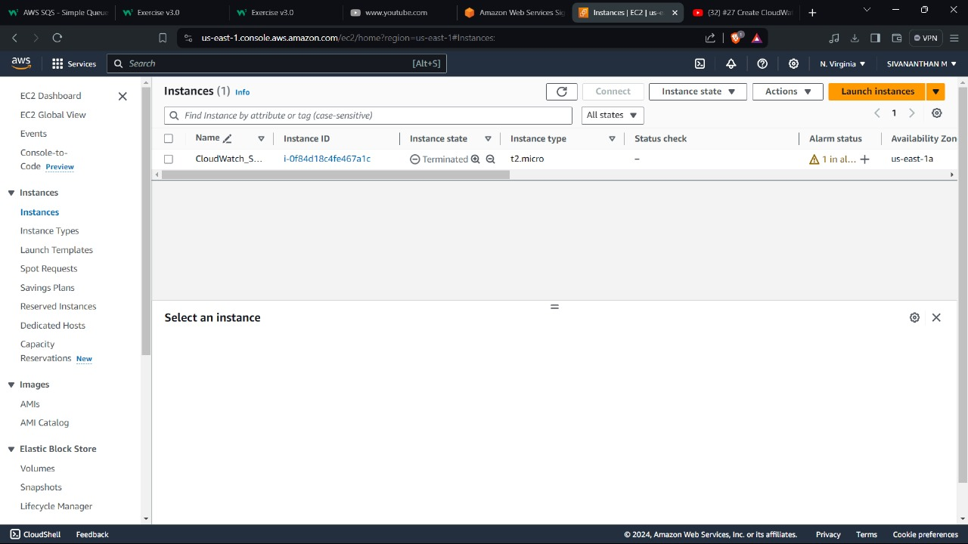

🡺THE MAIL SHOULD BE RECEIVED

